
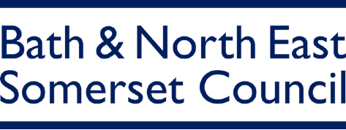

Easy
Read
Our Draft Local Plan

Easy Read
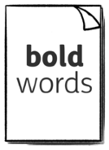
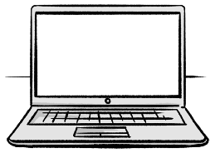
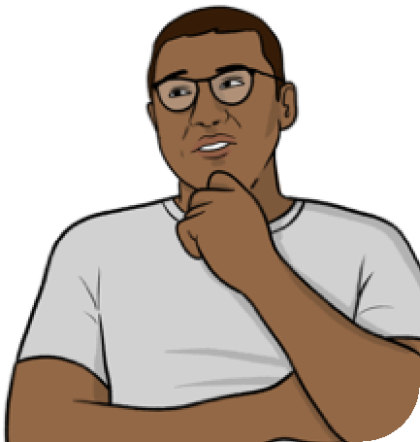
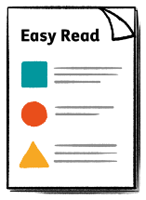
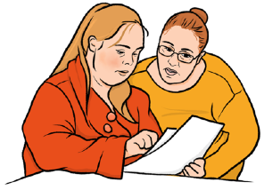
This is an Easy Read version of some information. It may not include all of the information but it will tell you about the important parts.

links

This
word
means….
This Easy Read booklet uses easier words and pictures. Some people may still want help to read it.
Some words are in bold - this means the writing is thicker and darker. These are important words in the booklet.
Sometimes if a bold word is hard to understand, we will explain what it means.
Blue and underlined words show links to websites and email addresses. You can click on these links on a computer.

What is in this booklet
About this booklet 4
About the Local Plan 5
Why we are writing a plan 7
The goals of the new Local Plan 8
Where we might make changes 11
How to learn more about the plan 13
What we are asking about 16
How to tell us what you think 17
What will happen next 19
Find out more 20

About this booklet
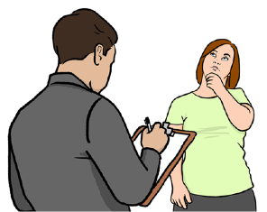
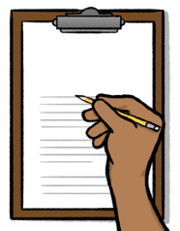
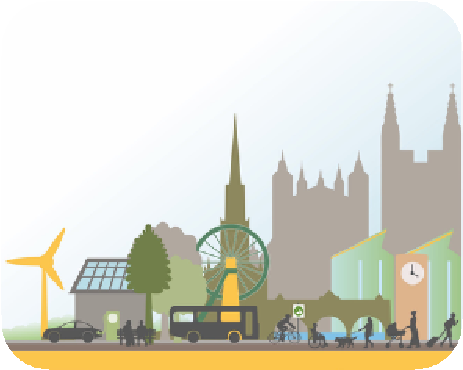

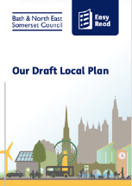
Bath and North East Somerset Council are writing a Local Plan.
Local Plan
The Local Plan is about what we want to happen in Bath and North East Somerset.
We have talked to lots of people who live or work in Bath and North East Somerset, and collected lots of information to write the plan.
This booklet will tell you more about the plan.
It will also tell you how you can let us know what you think about the plan, and what happens next.

About the Local Plan
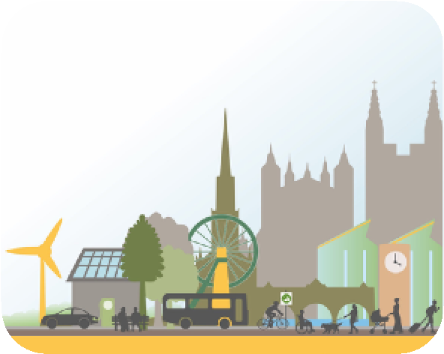
The Local Plan is about how places in Bath and North East Somerset will grow and change between now and 2043.
Change
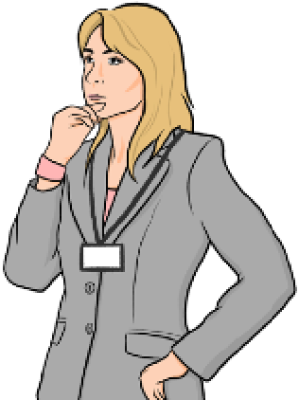
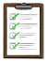
It says how we will decide what changes we will let happen.
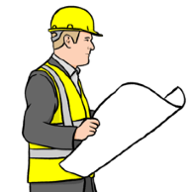
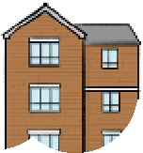

We know the area needs new homes and jobs, especially houses that more people can afford.
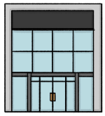
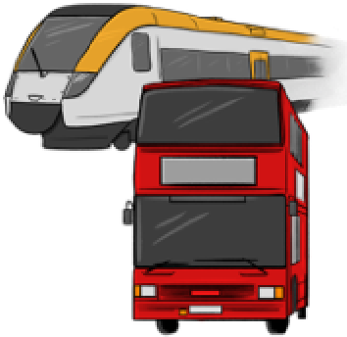
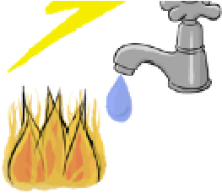
We will also need to have the right things in place for the people that will live and work here, like roads, buildings and power.
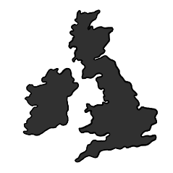
The plan talks about where the buildings, homes and jobs should be made.
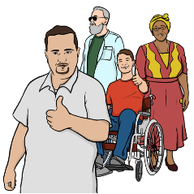
The plan is about making Bath and North East Somerset a happy and healthy place to live.

Why we are writing a plan

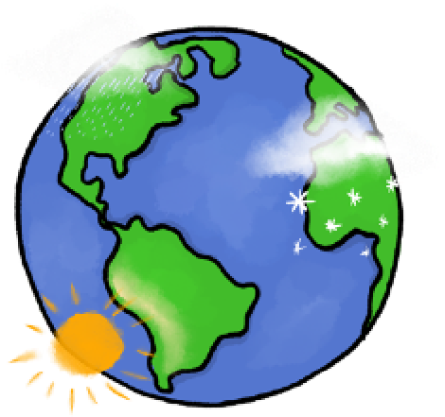
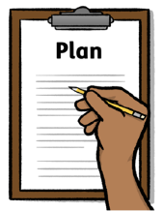
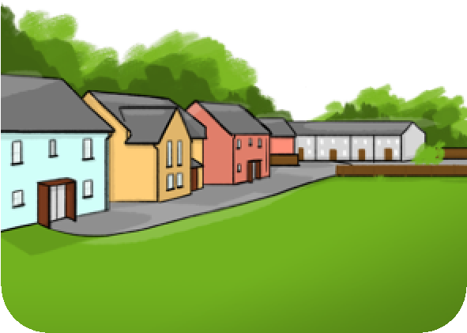
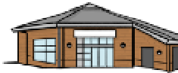

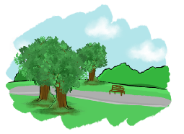
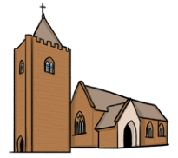
We know that life in Bath and North East Somerset will change.
Better
Change
We are writing a plan so that the changes make people’s lives better.
We also want to keep the good things about Bath and North East Somerset, like the beautiful buildings and nature.
We want to change how we do our work to help stop climate change and protect nature.
Climate change is all about big changes in the weather. For example, storms getting worse than they used to be. Or having less rain in some places.

The goals of the new Local Plan
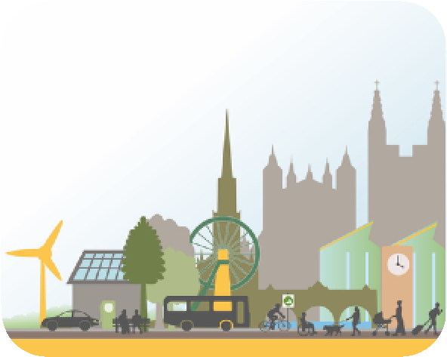

The goal of the Local Plan is to help us make Bath and North East Somerset a place where people want to live and work.
The plan will:
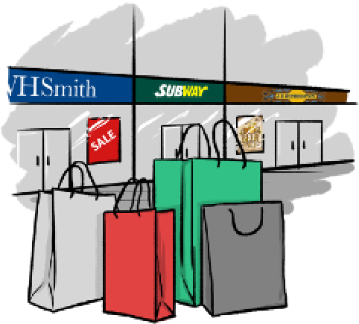
- Make the economy more fair for everyone.
The economy is the businesses, jobs and services in an area.
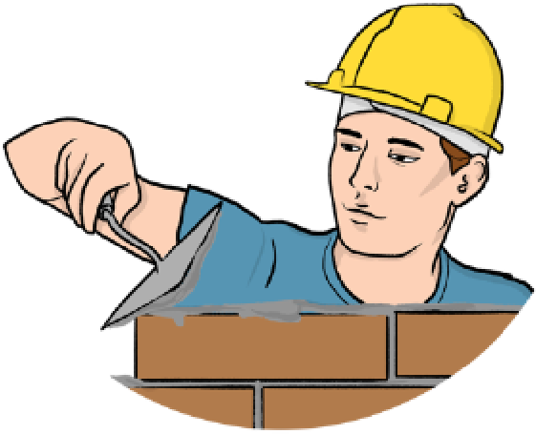
- Make sure we build more homes that people can afford to live in.
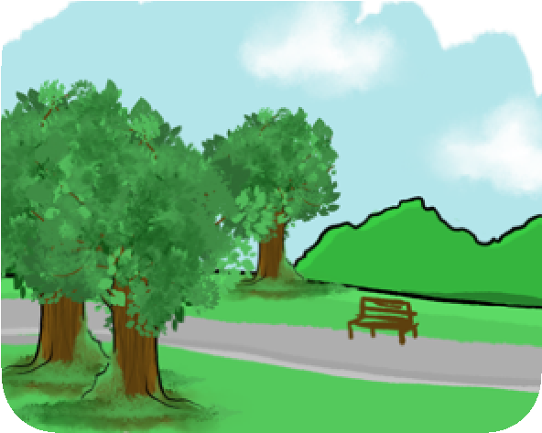
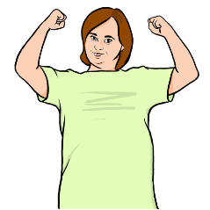

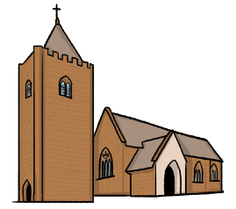
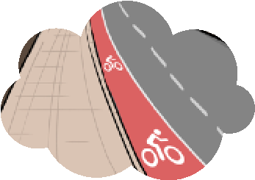
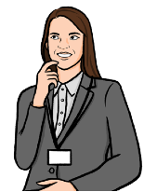
When we write our plan we must: • Make sure we look after nature and the planet.
- Help people be healthy and happy in their body and mind.
- Make it easier for people to travel without harming the planet.
- Look after our old buildings and places.
- Think about the things we need to put in place to support what we want to do, like roads, cycle paths, buildings and power.
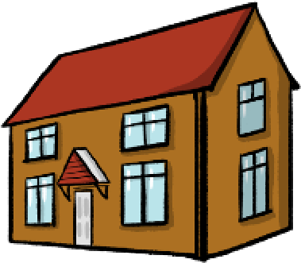
The government says that we need to build at least 27,000 new homes by 2043.
27
,000
The Local Plan explains where we will build these homes.
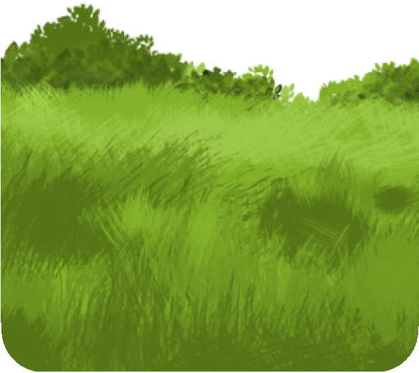
To build enough homes, we will have to build some homes on Green Belt land.
Green Belt land is land which is protected from building for nature.

Where we might make changes
We have already thought about some of the places where we might make changes, like:
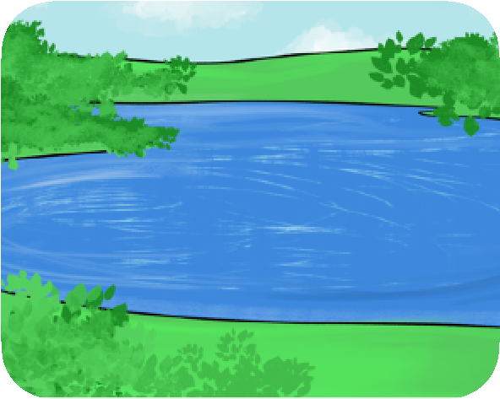
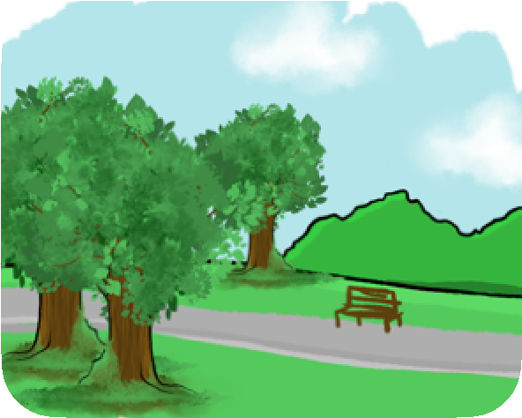
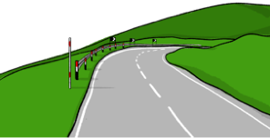
- Bath and around Bath.
Somer Valley
Bath
Bath to Bristol
- The area between Bath and Bristol called the Bath to Bristol Corridor.
- Somer Valley.
- Some parts of the countryside.
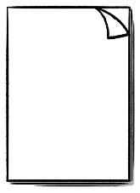
We have policies about where we can make changes.
Policies
Policies are rules for deciding where and how things like homes and parks can be built.
We are thinking about changing some of our policies and making new policies.
Policies
Change
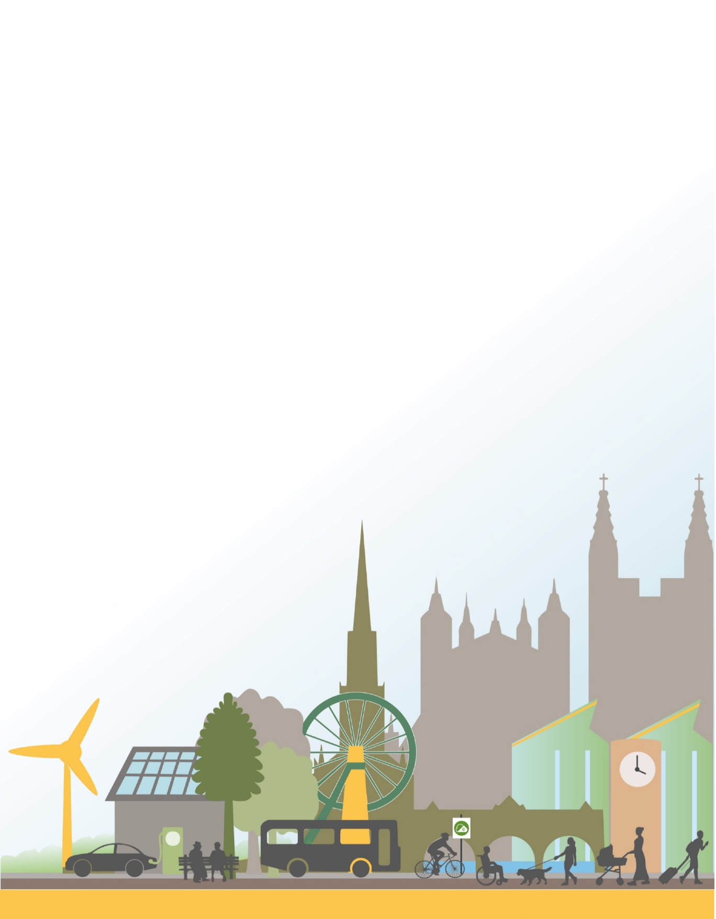
You can find out more about our policies in the Draft Local Plan.
Draft
Local Plan

How to learn more about the plan
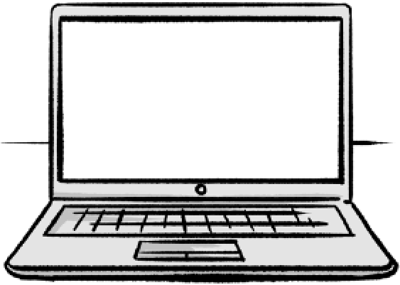
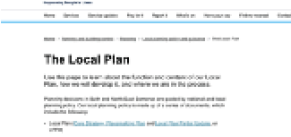
You can find out more about the plan and read the Draft Local Plan on our website here: www.haveyoursay.bathnes.gov.uk/localplan/
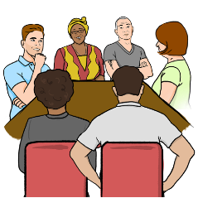
Some community meetings will be talking about the plan.
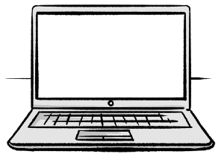

The meetings will be recorded, and you will be able to watch them on our YouTube channel:
www.youtube.com/@BathnesCouncil/ featured
There will be meetings in:
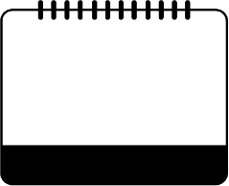
Bathavon Area Forum:

22

September
2026

- September, from 6:00pm to 7:00pm.
This is an online meeting, on Microsoft Teams.
Chew Valley Area Forum:

23

September
2026

- September, from 6:00pm to 7:30pm.
This is an in-person meeting at:
The Library
Chew Valley School BS40 8QB
Keynsham Area Forum.

24

September
2026

- September, from 6.30pm to 7.30pm.
This is an in-person meeting at:
Community Space
5 Temple Street
BS31 1HA
Parish Liaison:

21

October
2026

21 October, from 6:30pm to 8:30pm.
This is an in-person meeting at:
Community Space
5 Temple Street
BS31 1HA
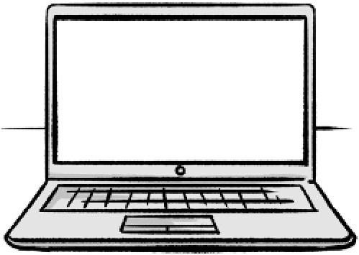
You can find out how to take part in the online meetings on our website: www.bathnes.gov.uk/area-forums

What we are asking about
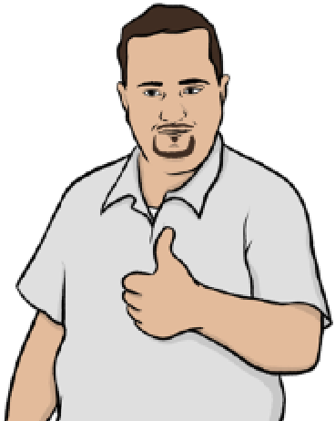
We want to know if you think this plan is ready to be checked by the government.
Before we send the plan to the government for checking, we need to make sure that it:
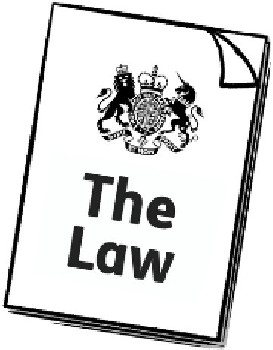 • Follows the law.
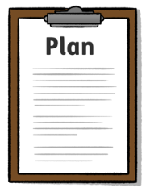

• Is a good plan that follows the government’s policies.
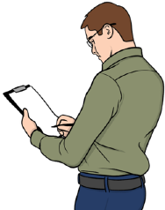 • Is ready to be checked.

How to tell us what you think
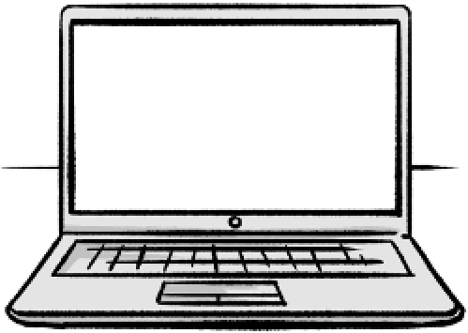
You can tell us if you think our plan is ready to be checked by the government on our website, here: https://beta.bathnes.gov.uk/local-plan
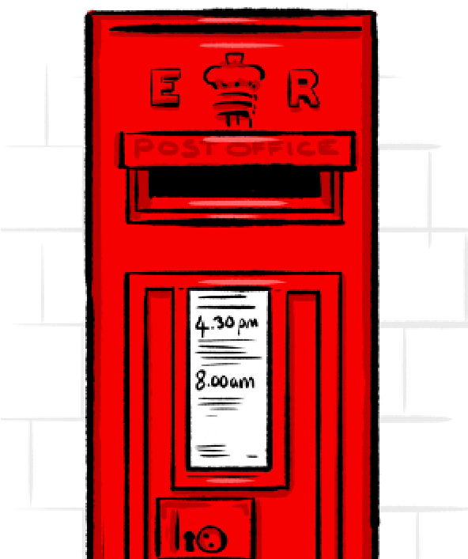
You can also write to us to tell us what you think, at:
Planning Policy
Bath and North East Somerset Council
Lewis House
Bath
BA1 1JG

You cannot tell us what you think by email.
Please contact us if:
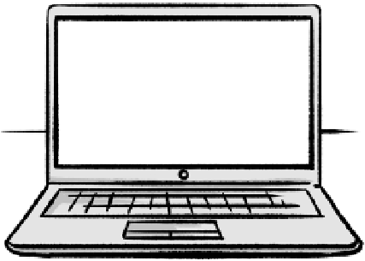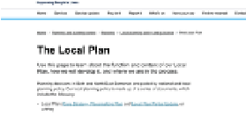 • You cannot answer on the website.
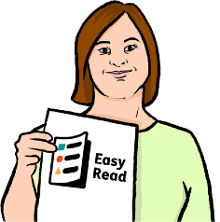
• You need the information in a different way, like Easy Read.
 We will be happy to help you.
If you want to tell us what you think, you must tell us by 30 October 2026.

30

October
2026

What will happen next

We will look at what everyone tells us about the Draft Local Plan.

We will send the plan and what people said about it to be checked by the government.
Plan
The government will check to make sure that the plan follows the law and government’s policies.
If the government says the plan is good, then it will become our final plan and we will start working on it.

Find out more
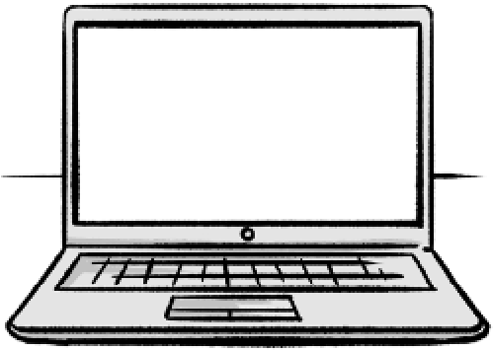
You can look at our website here: www.bathnes.gov.uk
This Easy Read booklet was produced by easy-read-online.co.uk
Some of our illustrations are based on images licensed from Shutterstock.

